**Assorted Baruch Quick Links, Office 365, Remote Connection, Zoom**

***(from Danny Cayas, Baruch College BCTC, 3/18/20)***

**QUICK LINKS**

* CUNYfirst Login - CUNY ([First+Last+2digits@login.cuny.edu](mailto:First+Last+2digits@login.cuny.edu)):

<https://home.cunyfirst.cuny.edu/oam/Portal_Login1.html>

* Blackboard CUNY Login ([First+Last+2digits@login.cuny.edu](mailto:First+Last+2digits@login.cuny.edu)):

<https://bbhosted.cuny.edu/webapps/login/noportal>

* Baruch Email OWA Login:   <https://mymail.baruch.cuny.edu/>
* CUNY Dropbox ([First+Last+2digits@login.cuny.edu](mailto:First+Last+2digits@login.cuny.edu)):

<https://dropbox.cuny.edu/>

* CUNY OneDrive ([First+Last+2digits@login.cuny.edu](mailto:First+Last+2digits@login.cuny.edu)):

<https://onedrive.live.com/about/en-us/signin/>

* CUNY Virtual Desktop Applications:

<http://www.cuny.edu/about/administration/offices/cis/virtual-desktop/>

* Zoom:

<https://baruch.zoom.us/>

* Portal Log-in CUNY:

<https://cunyportal.cuny.edu/cpr/authenticate/portal_login.jsp>

**TUTORIALS**

* Blackboard:

<https://www.cuny.edu/about/administration/offices/cis/core-functions/cuny-blackboard/user-guides/faculty/>

<https://www.baruch.cuny.edu/bctc/intech/Tutorials.htm>

* Blackboard Collaborate Ultra:

<https://www.cuny.edu/about/administration/offices/cis/core-functions/cuny-blackboard/user-guides/blackboard-collaborate-for-students-and-faculty/>

* CUNYfIRST:

<https://www.cuny.edu/about/administration/offices/cis/cunyfirst/training/>

<http://www.baruch.cuny.edu/cunyfirst/faculty.html>

* CUNY Dropbox:

<https://www.cuny.edu/about/administration/offices/cis/technology-services/dropbox/trainingresources/>

**E-MAIL SETUP (MOBILE DEVICES)**

* iPhone:   <https://www.baruch.cuny.edu/bctc/documents/OutLook_For_Iphone2b.pdf>
* Android:   <https://www.baruch.cuny.edu/bctc/documents/Outlook_for_Android2b.pdf>
* iPad:   <https://www.baruch.cuny.edu/bctc/documents/Outlook_for_iPad2b.pdf>

**OFFICE 365 INSTALLATION**

This can be installed on up to 25 devices, such as home desktop computers, laptop, iPad, etc.

Here's the instruction.

1. Browse to the Office ProPlus CUNY page.
2. <http://www.cuny.edu/officeproplus>
3. or
4. <http://www2.cuny.edu/about/administration/offices/cis/technology-services/office-pro-plus/>
5. Click the Microsoft Office 365 ProPlus (For Faculty and Staff) link
6. Click the "CUNY Web Applications Login page" link
7. Log in with your CUNYfirst username followed by @login.cuny.edu (e.g., [Jane.Doe16@login.cuny.edu](mailto:Jane.Doe16@login.cuny.edu))
8. Two options if only to run online Office (NOT INSTALL) and the second option to INSTALL Office apps.

IF YOU ONLY NEED TO RUN OFFICE APP ONLINE AND DON'T NEED TO INSTALL: To only run Office App from your device and NOT to install, click the MS office under Apps, for example click Word.

IF YOU NEED TO INSTALL OFFICE APPS ON THE DEVICE: To install Office apps, click Install Office at upper right. Then click Office 365 apps to download and install.

For iPad, iPhone:

Go to App Store and Search for Word, Excel, etc. and install the apps.

Open the app and sign in with your CUNYfirst username followed by @login.cuny.edu

**BCTC NEWS AND INFORMATION BLOG**

Campus closing due to COVID-19 disruption:

<https://blogs.baruch.cuny.edu/bctc/2020/03/13/resources-for-maintaining-business-continuity-during-a-potential-covid-19-campus-closing-resources-for-administrative-offices/>

**REMOTE CONNECTION**

*DOWNLOADING GLOBALPROTECT, INSTALLING ON HOME COMPUTER, AND CONNECTING TO THE BARUCH VPN SYSTEM*

1. Home Windows PC: [Baruch_VPN_Connection_PC.pdf](http://wsas.baruch.cuny.edu/docs/Baruch_VPN_Connection_PC.pdf)
2. Home Macintosh computer:  [Baruch_VPN_Connection_MAC.pdf](http://wsas.baruch.cuny.edu/docs/Baruch_VPN_Connection_MAC.pdf)

*Before following any of the steps 1-4 below, make sure that you've done the above GlobalProtect steps on your home computer, and you're logged on to the Baruch VPN system.*

1. [REMOTE CONNECT YOUR HOME WINDOWS PC TO YOUR OFFICE WINDOWS PC](http://wsas.baruch.cuny.edu/docs/RemoteDesktop_HomePC_to_OfficePC.pdf)
2. [REMOTE CONNECT YOUR HOME MACINTOSH COMPUTER TO YOUR OFFICE MACINTOSH COMPUTER](http://wsas.baruch.cuny.edu/docs/RemoteDesktop_HomeMAC_to_OfficeMac.pdf)
3. [REMOTE CONNECT YOUR HOME WINDOWS PC TO YOUR OFFICE MACINTOSH COMPUTER](http://wsas.baruch.cuny.edu/docs/RemoteDesktop_HomePC_to_OfficeMAC.pdf)
4. [REMOTE CONNECT YOUR HOME MACINTOSH COMPUTER TO YOUR OFFICE WINDOWS PC](http://wsas.baruch.cuny.edu/docs/Remote%20Desktop_HomeMAC_to_OfficePC.pdf)

*OPTIONAL:*

1. [CONNECT YOUR IPAD OR IPHONE TO YOUR OFFICE WINDOWS PC](http://wsas.baruch.cuny.edu/docs/iPad_iPhone_to_OfficePC.pdf)
2. [CONNECT YOUR IPAD OR IPHONE TO YOUR OFFICE MACINTOSH COMPUTER](http://wsas.baruch.cuny.edu/docs/iPad_iPhone_to_OfficeMAC.pdf)

**ZOOM (web conference):**   <https://baruch.zoom.us/>

**ZOOM Tutorial:**   <https://support.zoom.us/hc/en-us/articles/360029527911>

*Created an account recently in Zoom to test it. Quick steps I did, but tutorial above is more in detail.*

1. If you haven't created an account, you click the Sign In link
2. It will ask for your Baruch username and password.
3. If you have not registered, it will as to confirm your Baruch email. Click Confirm your email address.
4. You'll get an email from Zoom to your Baruch email. Click the link in your email.
5. You are now log in to Zoom; otherwise, browse to
6. <https://baruch.zoom.us/>
7. Click Sign In, it will ask for your Baruch computer login. Once logged in, you'll see your Zoom profile account.
8. Click Schedule a Meeting. Below is a sample of a class that is recurring every Tues & Thurs.

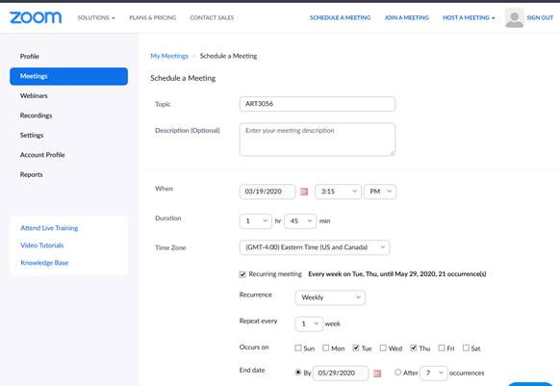

1. When done, click the Save button. You'll now see the meeting details. Click the Copy the invitation link.

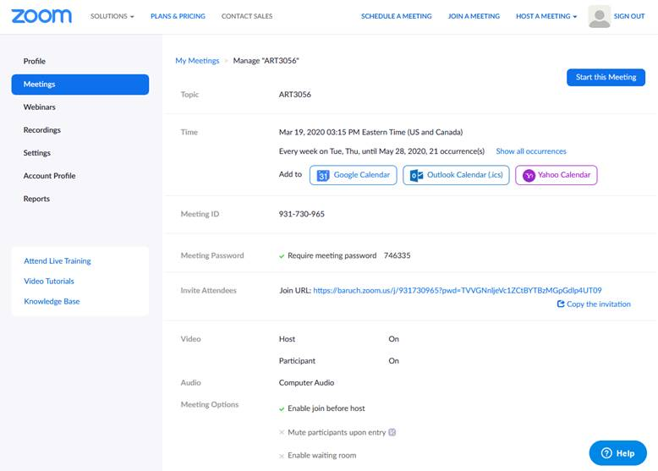

1. Click the Copy Meeting Invitation and paste to the content of your new message to the students in your class.

It shows the Meeting ID, Password, and Zoom Meeting Link for the students to click in their email.

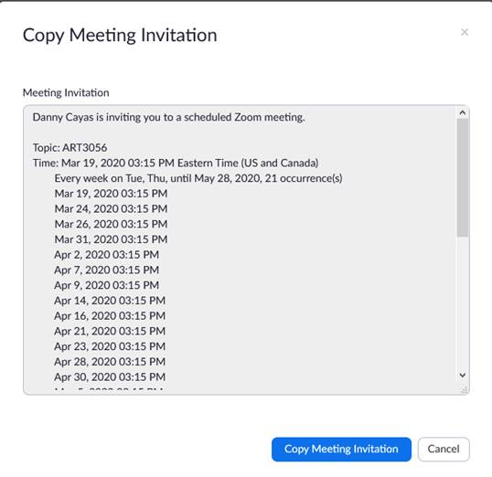

1. On the day of the class and time, click the start button to start the video conference.

If you have another class, click Schedule a New Meeting.

